Coding Contest-1

Hariharan J

727722eucs509

1)

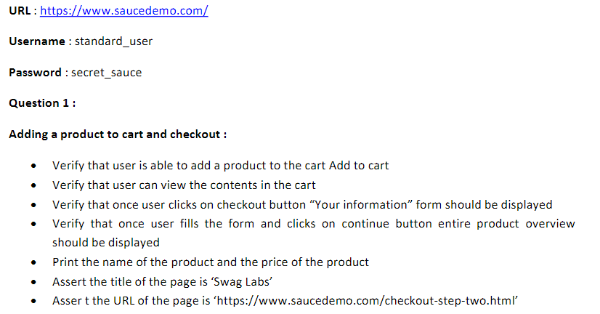

Coding:

package CC;

import org.openqa.selenium.By;

import org.openqa.selenium.WebDriver;

import org.openqa.selenium.WebElement;

import org.openqa.selenium.chrome.ChromeDriver;

import org.openqa.selenium.chrome.ChromeOptions;

import io.github.bonigarcia.wdm.WebDriverManager;

public class ques1 {

public static void main(String[] args) throws InterruptedException {

// **TODO** Auto-generated method stub

ChromeOptions co= new ChromeOptions();

co.addArguments("--remote-allow-origins=*");

WebDriverManager.*chromedriver*();

WebDriver d =new ChromeDriver(co);

d.get("https://www.saucedemo.com/");

d.manage().window().maximize();

Thread.*sleep*(3000);

WebElement uname=d.findElement(By.*xpath*("//*[@id=\"user-name\"]"));

uname.sendKeys("standard_user");

Thread.*sleep*(3000);

WebElement pass=d.findElement(By.*xpath*("//*[@id=\"password\"]"));

pass.sendKeys("secret_sauce");

Thread.*sleep*(3000);

d.findElement(By.*xpath*("//*[@id=\"login-button\"]")).click();

Thread.*sleep*(1000);

d.findElement(By.*xpath*("//*[@id=\"add-to-cart-sauce-labs-backpack\"]")).click();

String num=d.findElement(By.*xpath*("//*[@id=\"shopping_cart_container\"]/a/span")).getText();

if(num.equals("1")) {

System.***out***.println("Cart Added");

}

else {

System.***out***.println("Not Added");

}

Thread.*sleep*(3000);

d.findElement(By.*xpath*("//*[@id=\"shopping_cart_container\"]/a")).click();

if(d.findElement(By.*xpath*("//*[@id=\"cart_contents_container\"]/div/div[1]/div[3]/div[2]")).isEnabled()) {

System.***out***.println("Contents Shown");

}

else {

System.***out***.println("Not Shown");

}

Thread.*sleep*(3000);

d.findElement(By.*xpath*("//*[@id=\"checkout\"]")).click();

String info=d.findElement(By.*xpath*("//*[@id=\"header_container\"]/div[2]/span")).getText();

String einfo="Checkout: Your Information";

if(info.equals(einfo)) {

System.***out***.println("Your Information Page is Shown");

}

else {

System.***out***.println("Not Found");

}

Thread.*sleep*(3000);

WebElement fname=d.findElement(By.*xpath*("//*[@id=\"first-name\"]"));

fname.sendKeys("Sairam");

Thread.*sleep*(3000);

WebElement lname=d.findElement(By.*xpath*("//*[@id=\"last-name\"]"));

lname.sendKeys("V S");

Thread.*sleep*(3000);

WebElement pin=d.findElement(By.*xpath*("//*[@id=\"postal-code\"]"));

pin.sendKeys("788599");

Thread.*sleep*(3000);

d.findElement(By.*xpath*("//*[@id=\"continue\"]")).click();

Thread.*sleep*(3000);

String oview=d.findElement(By.*xpath*("//*[@id=\"header_container\"]/div[2]/span")).getText();

if(oview.equals("Checkout: Overview")) {

System.***out***.println("Product Overview Showed");

}

else {

System.***out***.println("Not Shown");

}

Thread.*sleep*(3000);

String pname=d.findElement(By.*xpath*("//*[@id=\"item_4_title_link\"]/div")).getText();

System.***out***.println("Product Name: "+pname);

String price=d.findElement(By.*xpath*("//*[@id=\"checkout_summary_container\"]/div/div[1]/div[3]/div[2]/div[2]/div")).getText();

System.***out***.println("Price: "+price);

String title=d.getTitle();

String eTitle="Swag Labs";

if(eTitle.equals(title)) {

System.***out***.println("Current Title is correct");

}

else {

System.***out***.println("No Match");

}

Thread.*sleep*(3000);

String Curl=d.getCurrentUrl();

if(Curl.equals("https://www.saucedemo.com/checkout-step-two.html")) {

System.***out***.println("Current Url is Correct");

}

else {

System.***out***.println("No Match");

}

d.close();

}

}

Output:

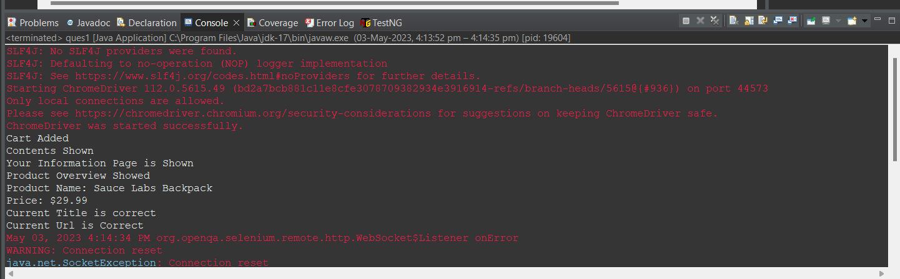

2)

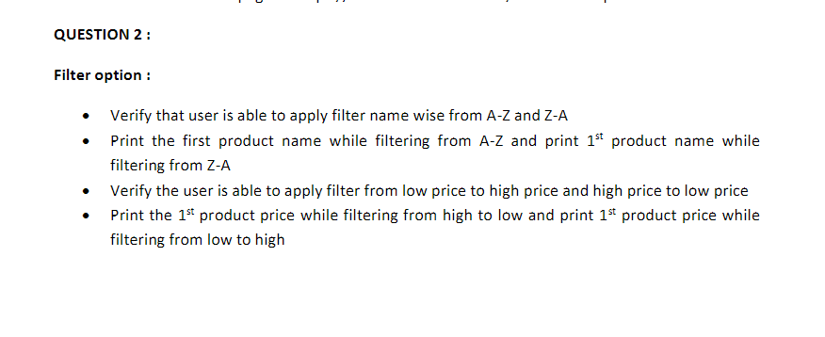

Coding:

package CC;

import org.openqa.selenium.By;

import org.openqa.selenium.WebDriver;

import org.openqa.selenium.WebElement;

import org.openqa.selenium.chrome.ChromeDriver;

import org.openqa.selenium.chrome.ChromeOptions;

import org.openqa.selenium.support.ui.Select;

import io.github.bonigarcia.wdm.WebDriverManager;

public class ques2 {

public static void main(String[] args) throws InterruptedException {

// **TODO** Auto-generated method stub

ChromeOptions co= new ChromeOptions();

co.addArguments("--remote-allow-origins=*");

WebDriverManager.*chromedriver*();

WebDriver d =new ChromeDriver(co);

d.get("https://www.saucedemo.com/");

d.manage().window().maximize();

WebElement uname=d.findElement(By.*xpath*("//*[@id=\"user-name\"]"));

uname.sendKeys("standard_user");

WebElement pass=d.findElement(By.*xpath*("//*[@id=\"password\"]"));

pass.sendKeys("secret_sauce");

d.findElement(By.*xpath*("//*[@id=\"login-button\"]")).click();

Thread.*sleep*(3000);

d.findElement(By.*xpath*("//*[@id=\"header_container\"]/div[2]/div/span/select")).click();

Thread.*sleep*(2000);

if(d.findElement(By.*xpath*("//*[@id=\"header_container\"]/div[2]/div/span/select/option[1]")).isEnabled()) {

System.***out***.println("A to Z enabled");

}

if(d.findElement(By.*xpath*("//*[@id=\"header_container\"]/div[2]/div/span/select/option[2]")).isEnabled()) {

System.***out***.println("Z to A enabled");

}

Thread.*sleep*(3000);

String name=d.findElement(By.*xpath*("//*[@id=\"item_4_title_link\"]/div")).getText();

System.***out***.println("A to Z :"+name);

Thread.*sleep*(3000);

Select se=new Select(d.findElement(By.*xpath*("//*[@id=\"header_container\"]/div[2]/div/span/select")));

se.selectByIndex(1);

System.***out***.println("Z to A : "+d.findElement(By.*xpath*("//*[@id=\"item_3_title_link\"]/div")).getText());

if(d.findElement(By.*xpath*("//*[@id=\"header_container\"]/div[2]/div/span/select/option[3]")).isEnabled()) {

System.***out***.println("Low price to High price is enabled");

}

if(d.findElement(By.*xpath*("//*[@id=\"header_container\"]/div[2]/div/span/select/option[4]")).isEnabled()) {

System.***out***.println("High Price to Low Price is enabled");

}

Thread.*sleep*(3000);

Select se2=new Select(d.findElement(By.*xpath*("//*[@id=\"header_container\"]/div[2]/div/span/select")));

se2.selectByIndex(3);

System.***out***.println("High to Low : "+d.findElement(By.*xpath*("//*[@id=\"item_5_title_link\"]/div")).getText());

Thread.*sleep*(3000);

Select se1=new Select(d.findElement(By.*xpath*("//*[@id=\"header_container\"]/div[2]/div/span/select")));

se1.selectByIndex(2);

System.***out***.println("Low to High : "+d.findElement(By.*xpath*("//*[@id=\"item_2_title_link\"]/div")).getText());

d.close();

}

}

Output:

